How to build a signed APK

**NOTE:** Make sure to save the keystore password, the key alias and the key password. You will need them later in this tutorial.

You can generate an app signing or upload key using Android Studio, using the following steps:

1. In the menu bar, click **Build** > **Generate Signed APK**.
2. Select a module from the drop down, and click **Next**.
3. Click **Create new** to create a new key and keystore.
4. On the **New Key Store** window, provide the following information for your keystore and key, as shown in figure 3.

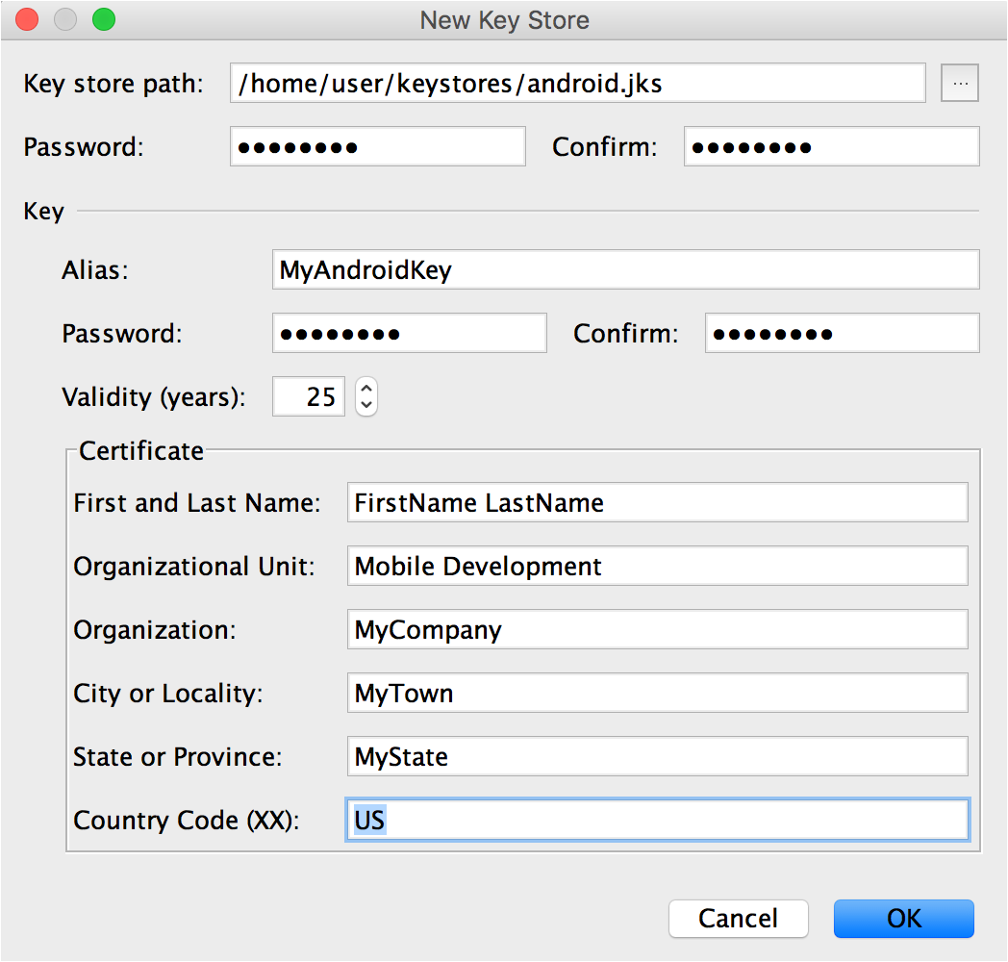

**Figure 3**. Create a new keystore in Android Studio.

**Keystore**

* + **Key store path:** Select the location where your keystore should be created.
  + **Password:** Create and confirm a secure password for your keystore.

**Key**

* + **Alias:** Enter an identifying name for your key.
  + **Password:** Create and confirm a secure password for your key. This should be different from the password you chose for your keystore
  + **Validity (years):** Set the length of time in years that your key will be valid. Your key should be valid for at least 25 years, so you can sign app updates with the same key through the lifespan of your app.
  + **Certificate:** Enter some information about yourself for your certificate. This information is not displayed in your app, but is included in your certificate as part of the APK.

Once you complete the form, click **OK**.

So far, so good. Now, to build a release apk, go to the Build menu and select Select Build Variant.

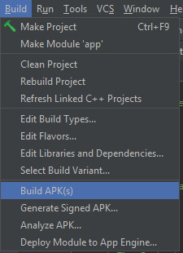

The following menu will appear on the left under the project files.

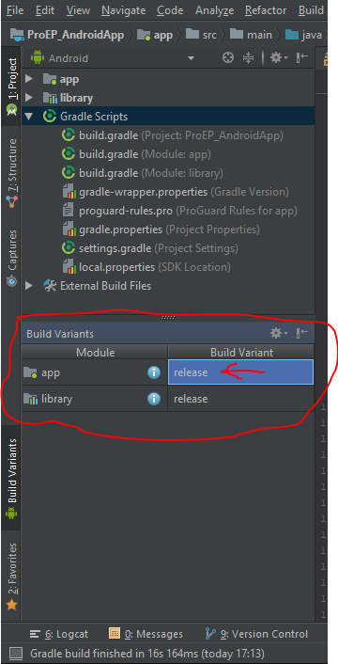

Make sure the build variant for the app module is release.

Now we have to use the key and the keystore we have created in the beginning. Go to the top where the module to be run is selected. Click to open the drop down menu and select Edit Configurations.

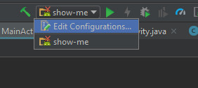

The following window should appear (see picture below).

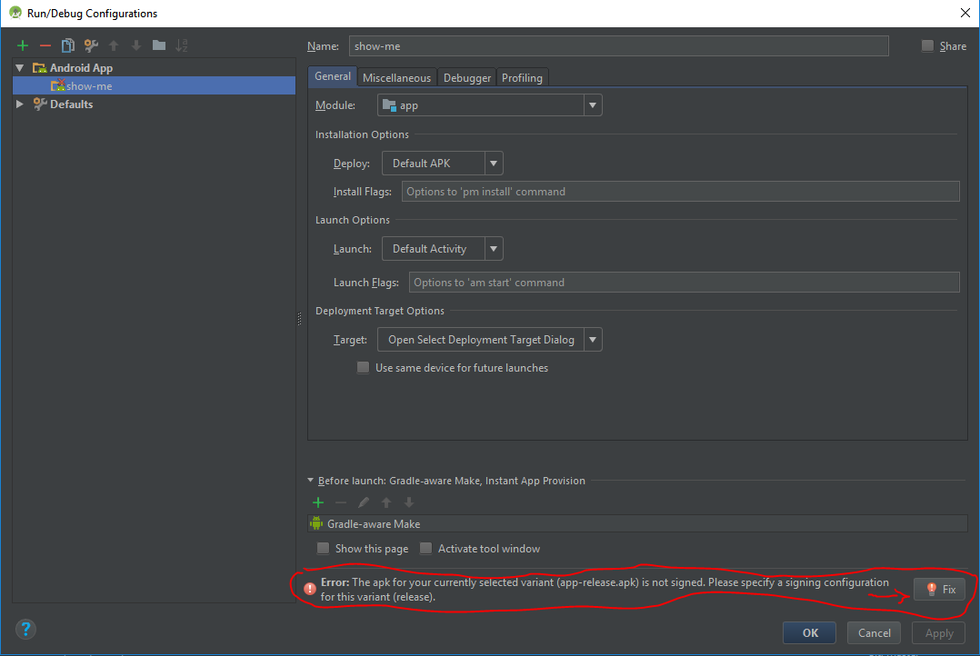

If there is no specified signing configuration the message circled in red should be visible. Click on the Fix button.

The Fix button should open the Project Structure window on the Signing tab.

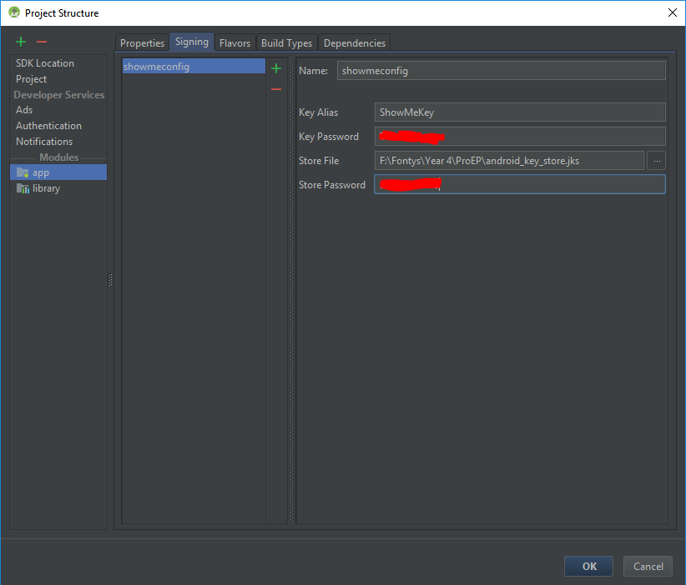

Create new configuration. First, click on the green plus to add new configuration. Then, give the configuration a name. The rest is filling the Key Allias, the Key Password, selecting the keystore file from the file system and providing the keystore password.

Navigate to the Build Types tab. Select the signing config, that you just created. Click OK to save all the changes.

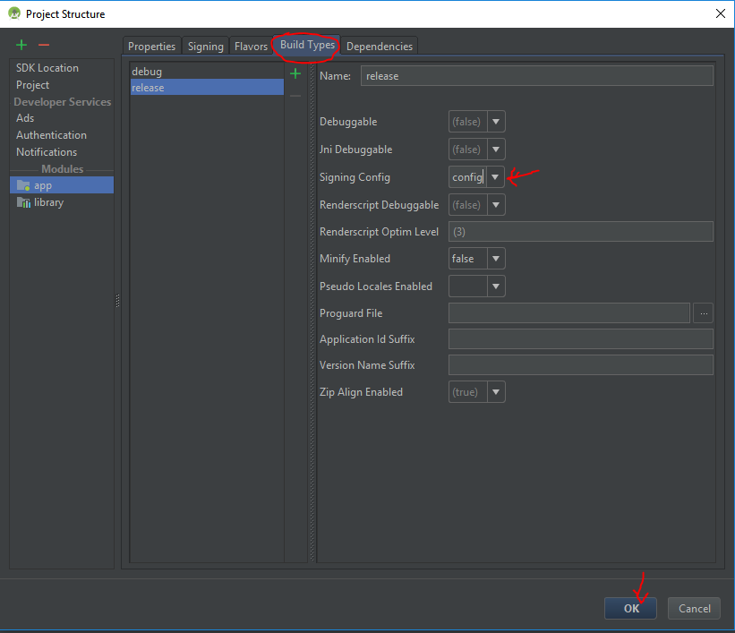

After that Android Studio will trigger an automatic build. To be on the save side of things go to the Build menu and select Clean Project (this will delete all the builds). After cleaning is done you can click on the build icon  or select Make Project from the Build menu.

The apk can be found in ProEP_AndroidApp\app\build\outputs\apk\release\app-release.apk.